# Machine Learning Model Tracking Document

## 1. Dataset Information

|  |  |
| --- | --- |
| Dataset Name: | Well 782 |
| Number of Samples: | 782 |
| Number of Features: | 4 (Tf, Rs, Gg, Api) |
| Target Variable: | Pb |
| Outlier Handling: | None |
| Feature Engineering Applied: | None |
| Scaling/Normalization Applied: | None |
| Encoding Applied: | None |

## 2. Preprocessing Steps

|  |  |
| --- | --- |
| Step | Description |
| Train-Test Split | 70% - 30% |
| Shuffling | Yes, using random_state=42 |
| Handling Missing Data | None |
| Feature Scaling | SVM only |
| Feature Selection | None |

## 3. Models Used & Hyperparameters

|  |  |  |
| --- | --- | --- |
| Model | Hyperparameters | Training Time |
| Linear Regression | None | 0.0007 |
| Ridge Regression | alpha = 0.001 | 0.0011 |
| Lasso Regression | alpha = 0.001 | 0.0021 |
| Decision Tree | max_depth = 4 | 0.0011 |
| KNN | n_neighbors = 5 | 0.0009 |
| SVR | C = 100.0, kernel = linear | 12.8890 |

## 4. Evaluation Metrics

|  |  |  |  |  |  |
| --- | --- | --- | --- | --- | --- |
| Model | MSE | RMSE | MAE | R² Score | Adjusted R² |
| Linear Regression | 241250.0 | 491.17 | 384.37 | 0.8158 | 0.8126 |
| Lasso Regression | 241250.0 | 491.17 | 384.37 | 0.8158 | 0.8126 |
| Ridge Regression | 241250.0 | 491.17 | 384.37 | 0.8158 | 0.8126 |
| Decision Tree | 226862.4 | 476.30 | 356.14 | 0.8268 | 0.8238 |
| KNN | 222437.7 | 471.63 | 361.29 | 0.8302 | 0.8272 |
| SVR | 211659.1 | 460.06 | 352.83 | 0.8384 | 0.8356 |

## 5. Cross-Validation Summary (5-Fold)

|  |  |  |  |  |  |  |
| --- | --- | --- | --- | --- | --- | --- |
| Model | RMSE Mean | RMSE Std | MAE Mean | MAE Std | R² Mean | R² Std |
| Decision Tree | 517.10 | 67.93 | 321.83 | 44.24 | 0.8330 | 0.0360 |
| KNN | 553.23 | 71.48 | 393.79 | 39.81 | 0.8126 | 0.0083 |
| Ridge Regression | 586.66 | 106.67 | 405.94 | 34.80 | 0.7904 | 0.0316 |
| Lasso Regression | 586.66 | 106.67 | 405.94 | 34.80 | 0.7904 | 0.0316 |
| Linear Regression | 586.66 | 106.67 | 405.94 | 34.80 | 0.7904 | 0.0316 |
| SVR | 651.21 | 138.53 | 450.23 | 70.81 | 0.7413 | 0.0573 |

## 6. Visualizations

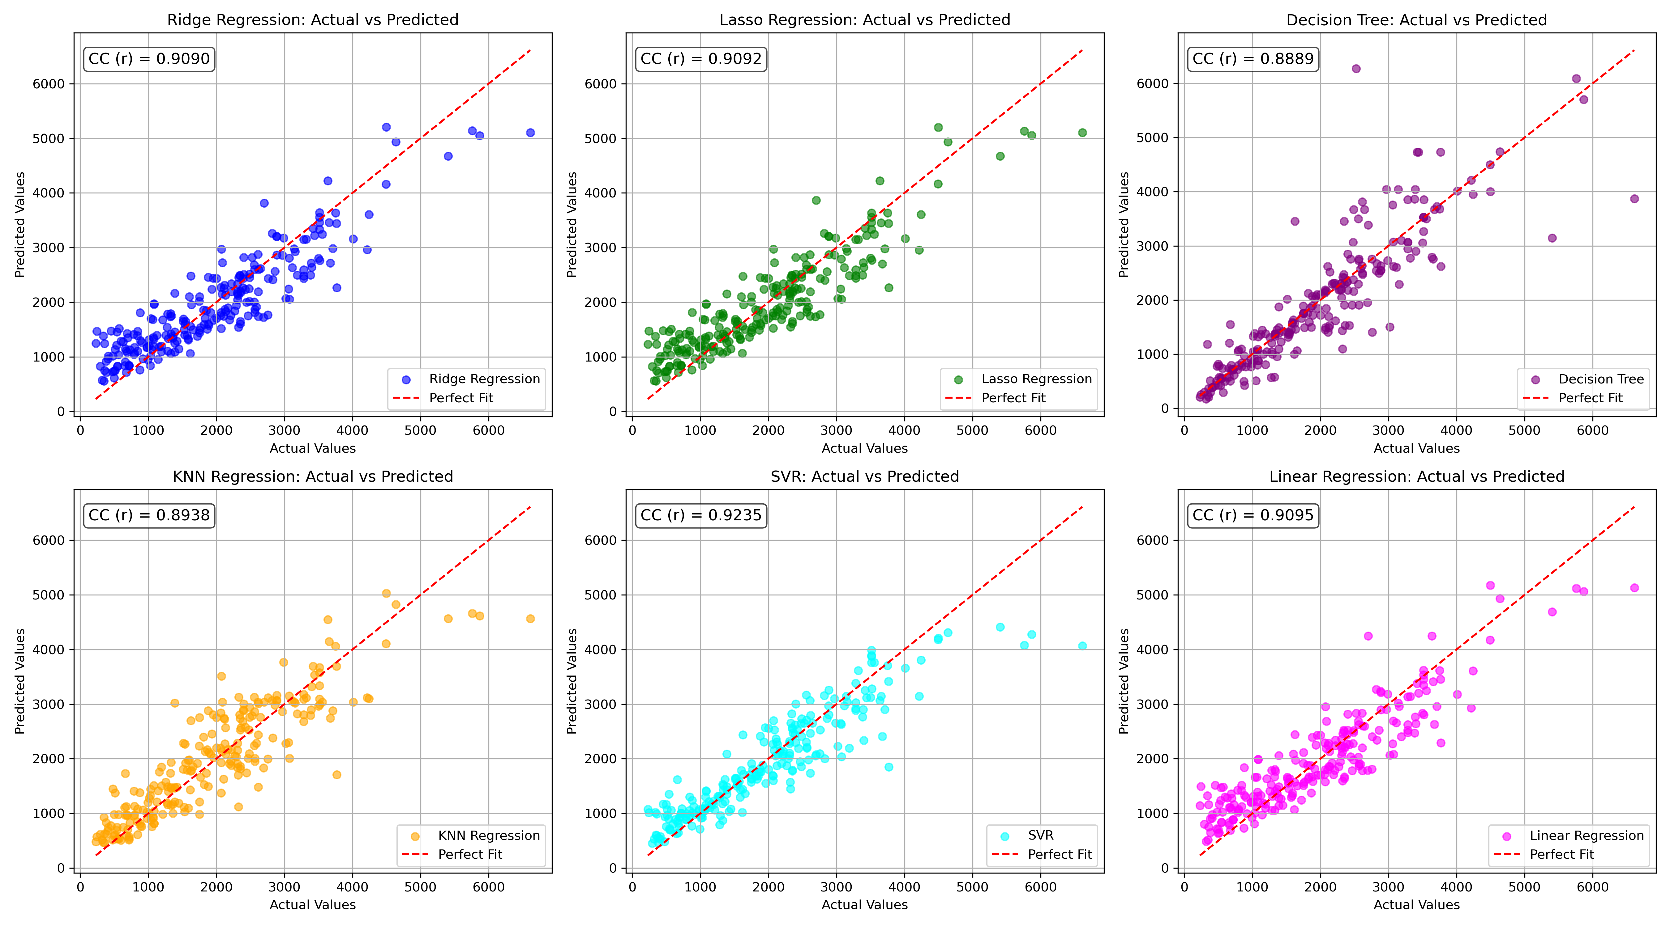

*Figure 1: Actual vs. Predicted Values for Pb (Well 782)*

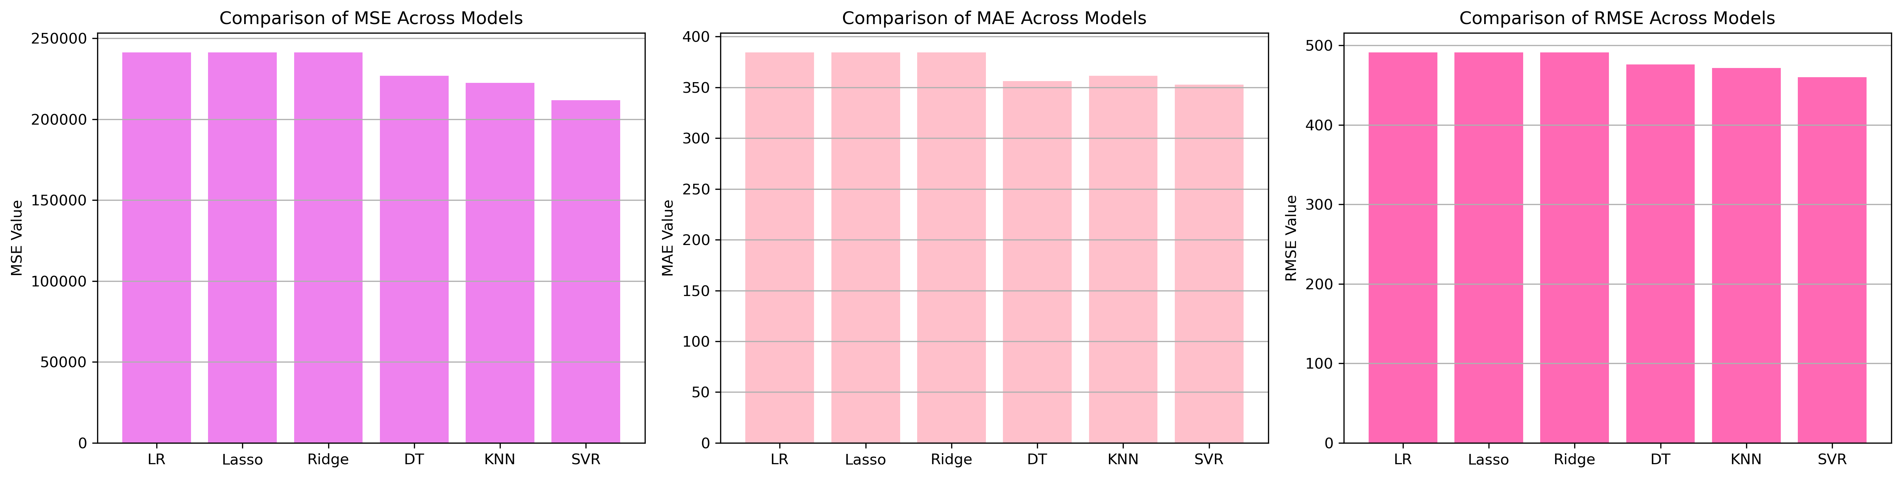

*Figure 2: Bar Charts of MSE, RMSE, MAE for Pb (Well 782)*

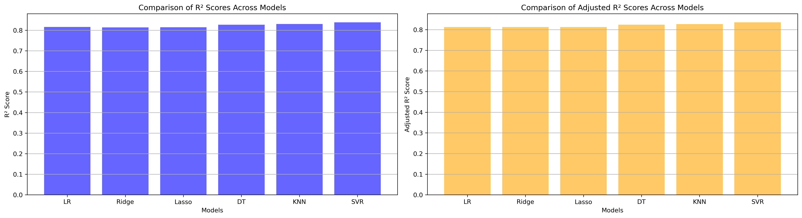

*Figure 3: Bar Charts of R² and Adjusted R² for Pb (Well 782)*

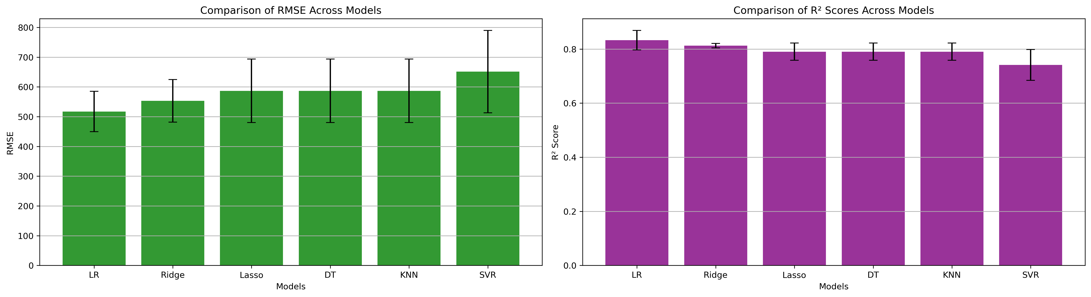

*Figure 4: Error Bars for RMSE and R² from CV for Pb (Well 782)*

### 7. Observations & Next Steps

* **Best Performing Model**: SVR (RMSE: ~460.06, R²: ~0.8384)
  + SVR performed better than other models on test set
  + All models scored R² between 0.74 and 0.84
  + Performance noticeably weaker than other wells (160, 283)

### 8. Code Access

The complete source code for data preprocessing, model training, evaluation, and visualization is [available here.](http://github.com/BoushBoo/pvt-prediction-ml-/tree/main) The repository includes organized Jupyter notebooks for each phase, dataset, and target, as well as requirements for reproducibility.